Safety Improvement Project Meeting: Dixie Hwy (Davisburg Rd to I-75)
Date: Tuesday, June 23, 2026
Time: 1:00 PM
Location: RCOC Administrative Office (31001 Lahser Road, Beverly Hills, MI 48025)
Agenda
- Introductions:
  - Road Commission for Oakland County (RCOC)
  - Springfield Township
  - Groveland Township
  - Holly Township
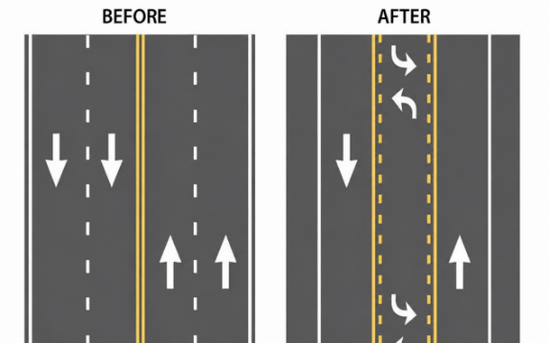
- Background: As part of the Safe Streets and Roads for All (SS4A) Grant Program to develop the 2025 RCOC Safety Action Plan, two safety studies were conducted on Dixie Highway, Davisburg Road to Grange Hall Road and Grange Hall Road to I-75.
- Safety Study Improvement Concept: Roadway Reconfiguration of the existing four-lane cross-section with two lanes in each direction to three lanes with one lane in each direction and a two-way center left-turn lane. In addition, installation of traffic signals at the Dixie Highway at Rattalee Lake Road and Dixie Highway at Holly Road intersections.
- Project Scope:
  - Reconfigure cross-section to three lanes (one lane in each direction and a center left-turn lane).
  - Signal installation at Rattlalee Lake Road and Holly Road intersections.
  - Intersection Realignment at Oak Hill Road (west leg).
  - Upgrade existing guardrail.
  - Cold-In-Place recycling of HMA pavement and 3.5’ HMA overlay.
- Project Segments:
  - Dixie Highway, Davisburg Road to north of Oak Hill Road, 2.4 miles.
  - Dixie Highway, north of Oak Hill Road to north of Grange Hall Road, 2.9 miles.
  - Dixie Highway, north of Grange Hall to I-75, 5.4 miles.
- Project Estimated Costs:
  - Dixie Highway, Davisburg Road to north of Oak Hill Road, $4,805,000.
  - Dixie Highway, north of Oak Hill Road to north of Grange Hall Road, $4,228,000.
  - Dixie Highway, north of Grange Hall to I-75, $6,813,000.
- Next Steps

